Introduction of DICP
The Dalian Institute of Chemical Physics (DICP) is located in the beautiful coastal city of Dalian, China. Over the past half century, research at DICP has addressed the economic and scientific needs of China. The Institute has built up an impressive portfolio of achievements, principally in the fields of catalysis, chemical engineering, chemical lasers, molecular reaction dynamics, organic synthesis, and chromatography for modern analytic chemistry and biotechnology. These achievements have contributed greatly to the economic and technological development of China.
Research at DICP is now focused on energy-related topics, and the Institute’s current development strategy is: focusing on sustainable energy research, and coordinating the multidisciplinary development of environment optimization, biotechnology, and advanced material by strengthening technological integration and innovation. DICP aims to play indispensable roles in national economy and security, and to become a leading research institute in the world.
Since its founding, DICP has produced numerous outstanding scientists and high-quality engineers who have developed strong domestic and international reputations. A total of 26 DICP scientists have been elected to the members of the Chinese Academy of Sciences (CAS), and the Chinese Academy of Engineering (CAE), four to the members of World Academy of Sciences, and one to the member of Academia Europaea. As of September 2019, DICP has over 1,500 employees, and 1,200 graduate students.

Introduction of DICP Postdoctoral Research Center
Established in 1985, DICP was one of the first postdoctoral research centers in China. It houses two national outstanding postdoctoral research centers respectively in chemistry, and chemical engineering and technology. At present, there are more than 220 postdoctoral researchers (including more than 20 international ones. DICP attaches great importance to the cultivation of post-doctoral talents, and many of its postdoctoral researchers have published papers in high-quality journals, such as Science, Angew. Chem, and JACS.
Salary System for Postdoctoral Researchers

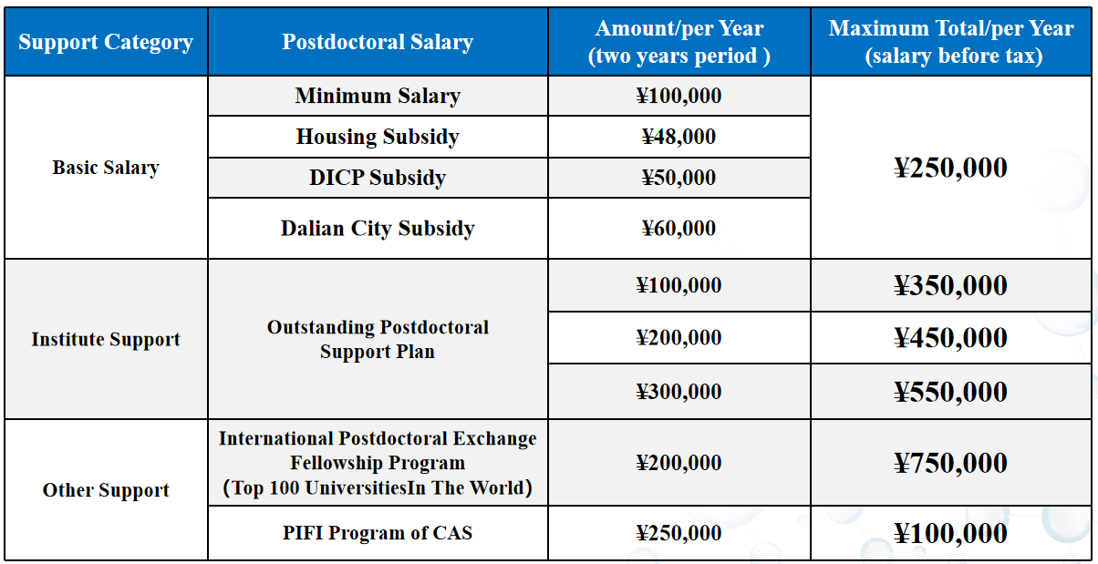

Living Facilities for Foreign Postdoctoral Researchers
DICP is located in the beautiful coastal city Dalian, surrounded by mountains and sea, and close to Xinghai Square, the largest square in Asia. Excellent geographical location enables easy access to transportation, shopping, entertainment, and other living facilities for foreign postdoctoral researchers.
In order to promote internationalization, Dalian Institute of Chemical Engineering has implemented a special project. Bilingual signs are available at office buildings, laboratories, dormitory, restaurants, and other areas in each park to facilitate use by foreigners.
DICP also provides fully equipped apartments for foreign postdoctoral researchers. The room has a kitchen, and a separate, fully furnished bedroom.

Personal Development
1. Upon finishing postdoctoral work, selected foreign postdoctoral researchers may become an employee of DICP, with an annual salary of USD$21,000/per year, and can also apply for a housing subsidy of USD$42,000 in total from Dalian City.
2. For foreign postdoctoral researchers becoming employees of DICP, and who received doctoral degrees from a Top 200 university in the world, they can enjoy a reward of USD$42,000 in total)for outstanding doctors from Liaoning Province.

Research Systom ：http://english.dicp.cas.cn/rh_17184/rs/

Minimum Requirements:
Applicants should have received a Ph.D. in a related field within the last three years, and be 35 years old or younger.
How to apply：
To apply for a postdoctoral position at DICP (including the “DICP Outstanding Postdoctoral Scholarship”), send a cover letter, a CV, and the names and contact information of three references to Mr. Chang LIU (liuchang@dicp.ac.cn) OR an identified DICP researcher with whom you have contacted before. All applications will be reviewed, and successful candidates will be contacted. Any questions about the postdoctoral program should be directed to Mr. Chang LIU.

Mr. Chang Liu
Personnel Department, Dalian Institute of Chemical Physics, Chinese Academy of Sciences
Add：457 Zhongshan Road Dalian, P.R. China（116023）
Tel：+86-0411-84379103
E-mail：liuchang@dicp.ac.cn

